The Brookvale House Project
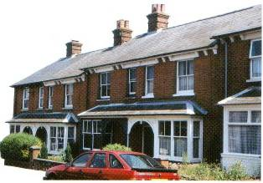
The Brookvale Project was a unique initiative highlighting the importance of the 'heritage' value and renewed interest placed on the late Victorian/Edwardian terraced house.
One of the principle aims of this project is to bring together the objectives of building conservationists and energy conservationists

.

The project illustrates that the special historic character of an older property does not have to be sacrificed in pursuit of modern living conditions and comforts and that older buildings can move with the times while retaining their special features. Community involvement is central part of the project.
The house purchased to demonstrate the objectives of the project is a very typical and modest terraced house dating from the Edwardian period. A number of its original historic features internally and externally had been 'modernised' or removed.
This has slowly eroded the character. For example, the timber sash windows had been replaced with single glazed aluminium windows in the 1970s. This has the adverse effect on the historic street scene and on the quality of the character and appearance of the conservation area as a whole. It is these relatively small changes which slowly erode the important overall character and are detrimental to a sense of history, quality and place. Brookvale has been designated a Conservation Area and therefore its historic importance has been acknowledged. However so often historic character can easily be eroded by well meaning but unsympathetic modernisation and alteration.

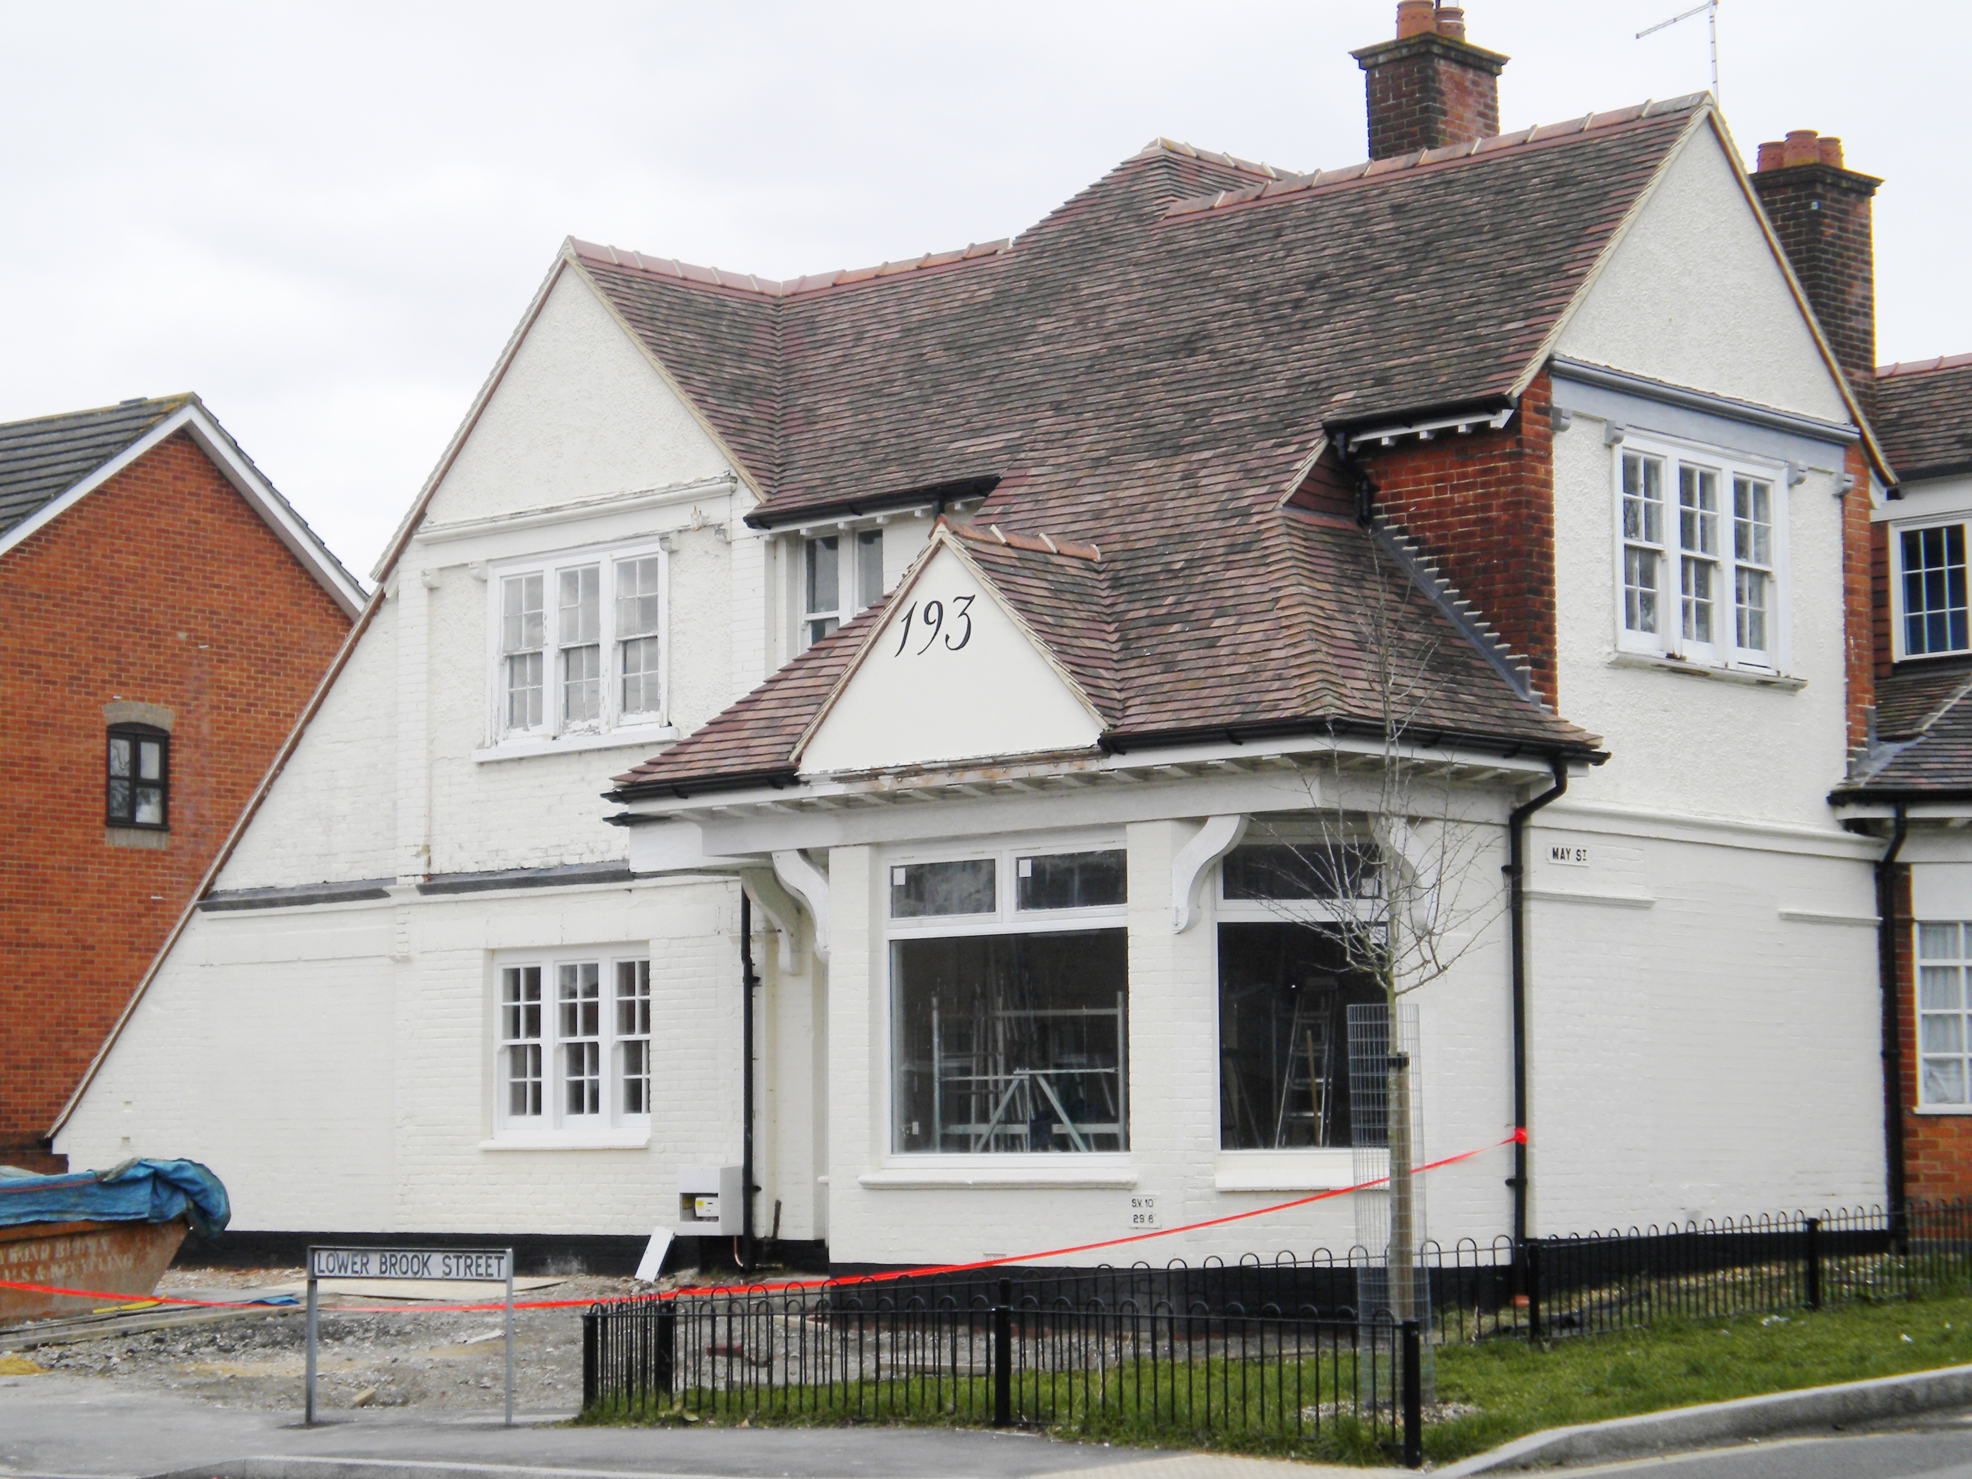

Historic Background
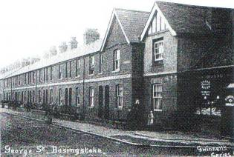
A survey of the town and manor of Basingstoke dated 1762 indicates the presence of hedged meadows and farmland with the river Loddon linking the area from West Ham Farm to the town of Basingstoke. The river is a strong link to the area's past and up until the 1880s a sheepwash was located on its banks in the area known as Brookvale.
The influence of John Thornycroft on the development of Brookvale cannot be underestimated. Thornycroft, head of a vehicle manufacturing company, identified Basingstoke, with its good rail links to London, relatively cheap land prices and ready stock of labour as the place to relocate his developing business. In 1898 the firm relocated from Chiswick to the area of Highfield House.
To provide the housing for the Thornycroft employees, Brookvale was laid out between 1898-1912 to the layout of roads, schools and public spaces that we see today. As well as houses there were corner shops, two builders’ yards and a Mission Hall.
The houses of Brookvale are typical of the housing stock built throughout the United Kingdom at the time, taking their plan and 'modern' facilities from emerging legislation on housing reform. As a direct result of the 1875 Public Health Act and the introduction of by-laws, each had its own toilet and plots were generous, with small gardens to the front and larger private gardens to the rear. The type of resident varied, as well as Thornycroft employees there were railway workers, also policemen and a caretaker for the local school.

The Character of Brookvale
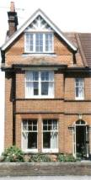
- The standardisation of building types and layouts largely derived from rapidly emerging legislation in the late 19th century and early Twentieth significantly affected the character and appearance of a large part of the developing industrialised nation.
- The style, scale and layout of Brookvale was being repeated throughout the United Kingdom, producing a good quality, generously proportioned standard stock of housing for the emerging group of manufacturing based, highly motivated blue and white collar workers.
The restrictions on the street layout, size of plot and uniformity of plan was firmly grasped by the speculative builder, who proceeded to define streets and terraces individually by varying standard items such as lintels, brick arches, bay windows, porches and elevation treatments to produce different designs which unified and defined roads and terraces.
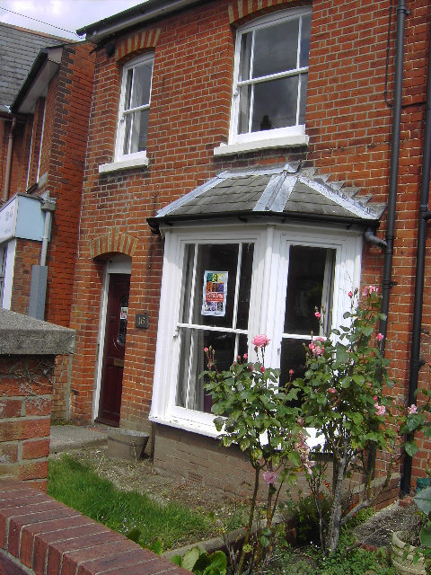

The harmonious and varied use of traditional materials, with the resulting subtle variation in textures and colours especially in the uniform rhythm of a terrace of houses, significantly contribute to the special character of Brookvale Conservation area.
It is particularly important to consider the following features if you intend to carry out any alterations to your house:

Roofs
The roof is an extremely important part of the character of the house. A good natural slate roof is hardwearing, displays an attractive patina of age and produces a uniform smooth, crisp finish to the terrace.

Chimneys
Chimneys form an important part of the character of Brookvale; they define rooflines and refine and accentuate the rhythm and repetition of the terrace.

Brickwork
The variation and contrasts of the type and colour of the brickwork significantly contributes to the character of the conservation area. Arches and window treatments also emphasise the uniformity and regular pattern of terraces as well as defining each group of buildings. String courses defined in different colour bricks also unify the terrace.

Windows

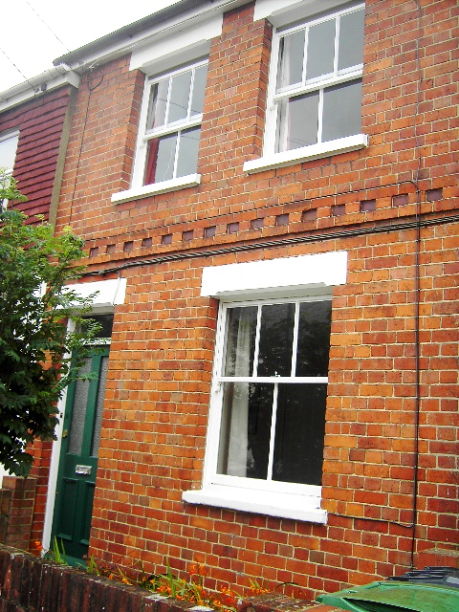
Windows are perhaps the most important single feature of the buildings within Brookvale. They unite terraces and can dramatically change the appearance of a building if changed for an alternative design or the same design in non-traditional materials.
The traditional sashes in Brookvale are characterised by slender glazing bars and horns to the upper sashes. They are set back from the external face of the brickwork and with original glass in place can produce pleasing, undulating planes and reflections which cannot be reproduced by modern equivalents

Doors
Doors are recessed into porches accentuated by the changing detail and treatment of the lintel and arch. Most doors have plain fanlights above. Original doors have a simple moulding to the timber frame. The loss of the original doors in Brookvale is perhaps the most variable feature, with a vast range of modern designs available which have a significant effect on the appearance of the houses and rarely relate to the traditional appearance and finish of the original designs.

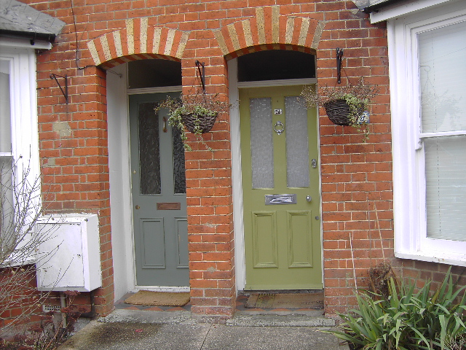

The Project House: 4 Queens Road
By using the house of educational purposes, the practical side of showing how an older terraced house can be brought up to a modern living and energy standards while retaining historic character can be demonstrated, There is increasing evidence to suggest that the retention and faithful reinstatement of such period features adds to the value of Victorian and Edwardian properties.
The project house was chosen to be representative of the type of problems and questions that would be present in the Brookvale area.
Completed Works:
- Roof: Replacement of concrete tiles with natural slate, insulation of roof using natural sheep's wool.
- Chimneys: Checking and repointing using lime mortar, replacement of lead flashing.
- Gutters: Replacement of cracked and broken plastic gutters and downpipes with cast iron ones.
- Front Elevation: Removal of paint and repair and repointing of brickwork.
- Windows: Reinstatement of timber framed vertical sliding sashes into existing sash boxes after removal of inset aluminium fixed lights.
- Doors: Replacement of aluminium door with new timber door to match original design. Reinstatement of glazing pattern to original back door.
- External: Removal of poorly constructed lean-to at rear and replacement with conservatory.
- Internal: Reopening and restoration of sitting room. Removal of model panel doors and fireplace. Removal of modern panel doors and replacement with new timber doors of four panels to match originals. Removal of later panelling from existing original doors. Removal of carpets, sanding and finishing of floor boards. Replacement of fittings to bathroom and kitchen. Redecoration throughout using 'environmentally friendly' paints.
The principles behind any decisions taken on the project house have been based on the following objectives.
- Original fabric is to be retained and repaired.
- Faithful reinstatement is to be carried out only where original features can be identified e.g. fireplaces.
- The project will promote energy conservation, without compromising the historic character.
- Sourcing and/ or identification of materials is to be undertaken with regard to sustainability arguments.
- The building should respect its historic past but present itself as a modern living unit.
- Performance of parts of the building can be improved as long as they do not compromise historic character/features.
- Each of the main tasks of work has been costed, to include the various different options which are open to the householder and which would not compromise the character and appearance of the Brookvale Conservation Area.

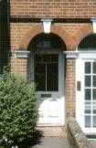
The Edwardian Terraced House Garden
Little has been recorded about this type of garden but consultation with the older residents has given us some clues. The front garden was usually a rectangle of lawn with a small bed in the middle which was planted with asters, marigolds and peonies and the like. The gardens had a low brick-built front walls surmounted by a railing. The path from the gate to the front door was of terracotta tiles of black and red laid in either a chequer or diamond pattern.
The larger rear gardens were simply laid out. Normally there was a straight path of cinders or beaten earth that ran from the house to the end of the garden. The fences were often of vertical boards but some gardens had hedges to form the boundary. Many of these gardens had rustic or bamboo pergolas which formed an attractive feature over the pathway. Little can be remembered by the older residents about planting of the rear gardens but it is known that plants such as sweet peas and carnations were very popular. As today the owners of these small gardens took ideas from much larger or grander gardens and implemented them in a more modest fashion.
Surprisingly very few vegetables were grown in these gardens. However, this is easily explained by examining local maps from 1910 which show the area to be surrounded by allotments.
The transformation of the garden speaks for itself. The major task was removing the damaged concrete path in the rear garden and then the laying of a path with a softer finish of bound gravel. Many existing plants were retained and new plants and new plants put in (all selected to be suitable for a garden of an Edwardian style). The front garden and the appearance of the property in general, has been greatly improved by the reinstatement of the traditional tiles path and walls and railings.
Much of the work in the garden has been carried out by volunteers from the local community under guidance of the Hampshire Gardens Trust.

Sustainability and Energy Efficiency in the House
Sustainability and energy efficiency are important issues. Concerns over pollution, ozone depletion, climate changes, the loss of rain forests and energy sources are growing all the time and the Governments across the world are beginning to take action.
There are also many simple and easy measures which can be undertaken in the home which will help to protect the planet for future generations and add to the quality of life.
Relevant work undertaken on the house and in the garden includes:

Materials
- Natural paints used throughout the house, they are healthier and far less wasteful in manufacture.
- The used of UPVC has been minimised because the material is damaging to the environment in its production and disposal.
- Sheep’s wool insulation is far less energy intensive in its manufacture than mineral fibre.

Energy Efficiency
- Why not save money off your fuel bills, help the environment and improve the comfort of your home with the following:
- Older timber sash windows do not have to be draughty. They can be draught-proofed to conserve energy.
- Lofts, walls and floors benefit from insulation.
- Modern highly efficient heating systems and controls deliver the right amount of heat, at the right place at the right time.

Water Conservation
As the number of homes in the region increases, demand and the cost of water is also rising:
Grey water recycling is fitted in the house. Bath and sink water is filtered, treated and used for toilet flushing - cutting water usage by up to 33%.
A water butt collects rainwater for the garden.
For further details concerning the Brookvale project contact the Planning & Transportation Department, Basingstoke & Deane Borough Council. Tel. 01256 845414 (Switchboard Tel. 01256 844844)

