
REPORT OF THE TRUSTEES FOR THE YEAR ENDED 30th April 2014

The Trustees are pleased to present their report together with the financial statements of the charity for the year ended 30th April 2014.

BCA Trustees for the year ending 2013/2014

CHRISTOPHER JOHN HALL
PAMELA MANSFIELD
MALCOLM MACINNES
CATHY WILLIAMS
HELEN CAMPER
JOE WESTON
MARTIN HEATH
CATHY MAWER TED SQUIRES

BCA Governing Document
Brookvale Community Association (BCA) is a charity governed by its constitution that was adopted 24th February 1975 and updated May 2008. It is registered as a charity with the Charity Commission. Charity No 269386

BCA Appointment of Trustees
Trustees and honorary officers are elected by the members at the AGM. The trustees shall retire from office at the end of the annual general meeting three years after his or her appointment but shall be eligible for re-election. Trustees can be nominated by members associate members or existing Trustees.

BCA - the Objects of BCA
To promote the benefit of the inhabitants of Brookvale and the neighbourhood (hereinafter called 'the area of benefit') without distinction of sex or of political, religious or other opinions, by associating the local authorities, voluntary organisations and inhabitants in a common effort to advance education and to provide facilities in the interests of social welfare for recreation and leisure time occupation, with the object of improving the conditions of life for the said inhabitants.

To establish and secure the Village Hall (hereinafter called the 'Hall') and to maintain, or to co-operate with any local statutory authority in the maintenance and management of such a Hall for activities promoted by the Association and its constituent bodies in furtherance of the above objects.

To promote such other charitable purposes as may from time to time be determined.

The Association shall be non-party in politics and non-sectarian in religion. The area of benefit shall be Brookvale and the neighbourhood together defined by Basingstoke.

BCA Public Benefit for the Year Ending 2013/2014
Events organised by BCA included the fifth year of Brookvale in Bloom. The event gave local residents the opportunity to become involved in Brookvale in Bloom which aims to make Brookvale a beautiful place to live and to support local residents understanding of the Conservation Area relating to Brookvale.

The January Panto was Alice In Wonderland, produced by Proteus. This was a very enjoyable event with good feedback from the audience, cast and volunteers!

The Coach trip to Hayling Island in August was a good day out for non-drivers, which we hope to repeat in future.
The Halloween kids disco was a great success, which will be repeated

The lottery continues to go from strength to strength and BCA thank Pamela Mansfield for her continued commitment to enlisting new lottery members and making it the success it is. Funds from the lottery will go towards the Hall redevelopment.

The Blurb (newsletter) and the website continue to offer information to the community of Brookvale about what’s going on. This year BCA managed to produce 4 Blurbs going out to over 1200 homes each time. The committee would like to thank those (Malcolm and others) that help to pull the Blub together and those volunteers that distribute it. The BCA also has a very active Facebook page, to distribute up-to-date news, and get views and feedback from the community.

Hiring of the hall was taken up by many people from the Brookvale community and surrounding area as well as the regular hirers that make up our core income.

The Development Sub Committee continues to work on behalf of the Brookvale community to ensure developments are what the local residents want and that issues of access around Brookvale are addressed so that residents with mobility constraints and parents with pushchairs can continue to move around Brookvale in a safe manner.

Grants
BCA was very lucky in 2013/14 receiving a grant from Hampshire County Council of £6,250 towards refurbishing the kitchen & windows.

BCA Reserves Policy
It is the policy of the charity to maintain free reserves at a level that balances our objective to develop and support services with our need to remain financially stable. A minimum level of free reserves equating to at least 6 months of unrestricted expenditure is considered sufficient to cover management, administration and support costs and to respond to emergency needs which arise from time to time.

Assets Managed by the Trustee
BCA manages Brookvale Village Hall and fundraise to maintain and develop the building and ensure the building is there for community use. The building is currently provided by the Basingstoke and Deane Borough Council for a “peppercorn” ground rent and free of business rates. The Council do not envisage an increase in charge for these costs being made against the Charity in future years.

Note from Chair of Trustees
2013/14 has been a challenging yet successful year for BCA due to the support given by volunteers. The charity has managed to deliver more community events/activities and maintain the hall successfully, unsupported by grants.
However the committee needs more volunteers to continue to deliver our community events as volunteer resources are dwindling. I have to thank these volunteers for the support they give. Without them the community would not have a hall and I am very grateful to their ongoing support.

The solar panels funded by Developers Contributions, known as Section 106, continue to cut costs and provide income. The BCA has also been actively interested in the future of Saunders Field, a wild place west of our area, under threat of development as part of the Leisure Park regeneration.
Events continued to be attended by the community with Brookvale in Bloom promising to be another success next year.
Work on the Hall upgrade has continued throughout the year, delayed by almost constant rain from October to March! The main contract is now complete, and Brookvale has a facility to be proud of. Our continuing thanks to the volunteer team that is making the project happen. This project will involve a lot of hard work in the coming months to finish internal decoration & fittings.
The Community Garden planning has started, now we have Permission to Garden the land beyond the Hall grounds. Everyone with any skills with computer or pickaxe is invited to join in!

Finally - Many thanks to all those that supported the BCA in 2013/14. Let’s hope the success continues into coming years.

Signed | . |  |  | Chair | Date | ......7/8/2014......

BCA Lottery Statement for the Year Ending 2014

Brookvale Community Association - Supporters Lottery 2013 - 2014
 |  | db | cr
B/F 01/05/2013 |  |  |  | £983.14
Collections |  |  | 1395.00
Draw |  | 1200.00
Interest |  |  | 0.05
Tax |  | 0.01
Donations |  |  | 3.80
 |  | 1,200.01 | 1,398.85 | £198.84
Balance |  |  |  | £1,181.98
Nationwide account |  |  |  | £1,205.68
due to Promoter |  |  |  | - £23.70
 |  |  |  | £1,181.98
Members 121
(Increase of 16)
Promoter: Pamela Mansfield

P Mansfield 19/6/2014

 | Brookvale Community Association
 | Draft - Receipts and Payments Account for Financial Year Ending 30th April 2014
 | Charity No 269386
 | Receipts |  |  | 2014 |  | 2013
 | Blurb adverts |  |  | £0.00 |  | £0.00
 | Hall Hire |  |  | £7,296.91 |  | £7,610.14
 | Events |  |  | £655.20 |  | £620.61
 | Donations |  |  | £4.91 |  | £160.97
 | Current Account Interest |  |  | £0.00 |  | £0.00
 | Deposit Account Interest |  |  | £0.00 |  | £0.00
 | Grants |  |  | £6,250.00 |  | £2,000.00
 | Transfer from Supporters Lottery |  |  | £0.00 |  | £0.00
 | s106 | Developers | funds | £242,945.52 |  | £4,423.29
 | SSE FIT |  |  | £3,733.78 |  | £1,338.53
 | Rent refund 2008/12 |  |  | £0.00 |  | £800.00
 | Santander bond inc interest |  |  | £8,252.98 |  | £0.00
 | Other |  |  | £168.60 |  | £0.00
 | Total Receipts |  |  | £269,307.90 |  | £16,953.54
 | Payments
 | Hall
 |  | Ground rent |  | £0.00 |  | £137.50
 |  | Utilities |  | £1,356.24 |  | £840.14
 |  | Maintenance - |  | £927.75 |  | £255.00
 |  | Building works - hall ex tn |  | £242,963.52 |  | £4,423.29
 |  | Cleaning |  | £2,715.51 |  | £2,632.24
 |  | Hall refunds |  | £161.99 |  | £90.00
 |  | Insurance |  | £1,889.71 |  | £1,767.80
 |  | Equipment Purchase |  | £109.02 |  | £508.93
 |  | Safety Protection/ Certification |  | £214.74 |  | £193.92
 |  | Sub-Total |  | £250,338.48 |  | £10,848.82
 | Administration including
 | stationery & mobile |  |  | £142.32 |  | £96.98
 | Events |  |  | £983.09 |  | £1,233.31
 | Blurb |  |  | £335.00 |  | £381.00
 | Staff training |  |  | £0.00 |  | £0.00
 | AGM |  |  | £15.25 |  | £0.00
 | Other |  |  | £168.00 |  | £750.00
 | Total Payments |  |  | £251,982.14 |  | £13,310.11
 | Net Receipts (Payments) |  |  | £17,325.76 |  | £3,643.43
 | Bank Balance on 30/4/14 30/4/13 |  |  | £27,615.39 |  |  |  | £10,177.63
 | Lottery credit balance |  |  | £1,181.98 |  |  |  | £983.14
 | Cash held for float |  |  | £45.47 |  |  |  | £47.66
 | Santander bond |  |  | £0.00 |  |  |  | £8,016.83
 | Santander account interest |  |  | £0.00 |  |  |  | £0.37
 |  | Total assets |  | £28,842.84 |  |  |  | £19,225.63
 | NB Hall hire damage deposit cheques are not cashed as the money is not due to BCA until
 | any damage is itemised and invoiced. S106 funds only pass through the BCA account
 | Signed | 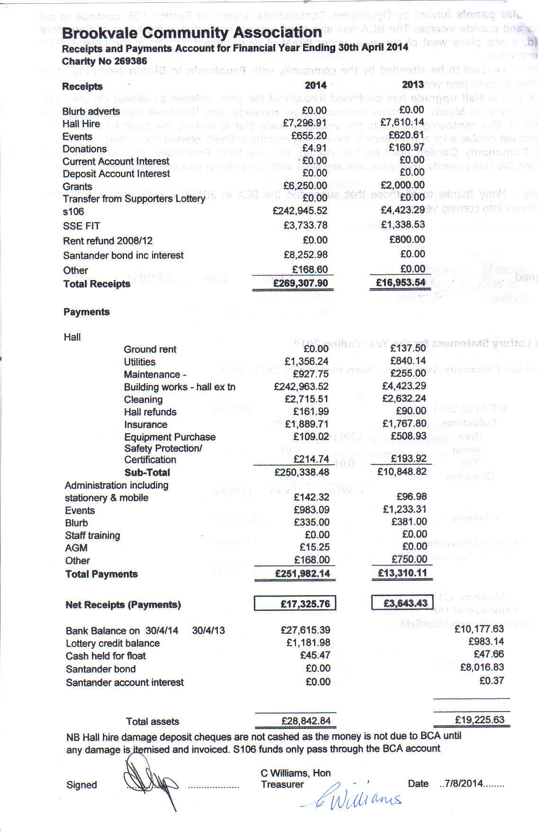............ | ................... | C Williams, Hon Treasurer |  | Date | ..7/8/2014........
 | Signed | ....... | ................... | H Camper | Chair | Date | .7/8/2014.........

